07/07/2026 Git and GitHub Task-1

- Create a GitHub account

Step 1: Open GitHub
Go to:
GitHub

Step 2: Click Sign up
Click the Sign up button in the top-right corner.

Step 3: Enter Your Email
Enter your email address and click Continue.

Step 4: Create a Password
Create a strong password and click Continue.

Step 5: Choose a Username
Ex syedsarfaraz179

Step 6: Complete the Verification

Step 7: Verify Your Email

Step 10: Create Your First Repository
After logging in:
Click the + icon (top-right).
Select New repository.
Repository name:
Techie horizon
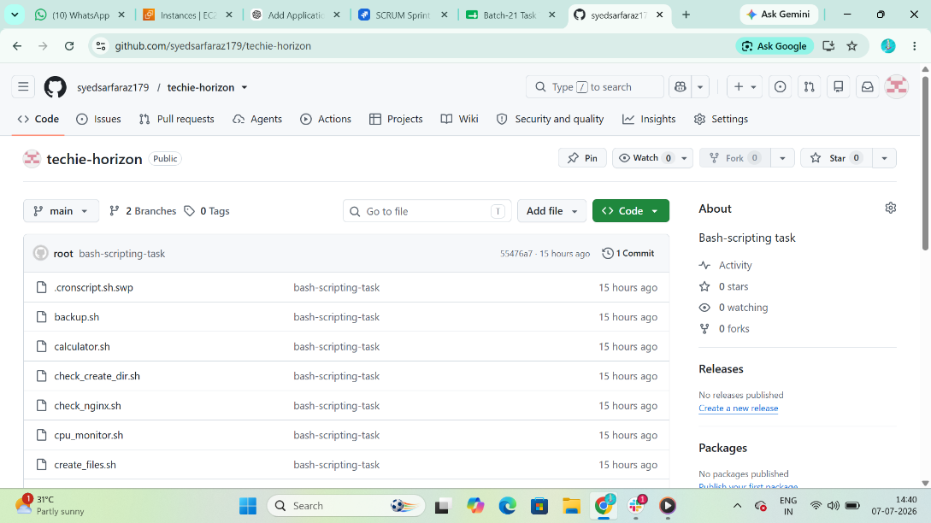
- Required Steps: Set Up MFA (Multi-Factor Authentication) for GitHub Using a Mobile App

Step 1: Sign in to GitHub

Go to:
GitHub
Log in to your account.

Step 2: Open Settings
Click your profile picture (top-right).
Click Settings.

Step 3: Open Password and Authentication
In the left menu, click:
Password and authentication

Step 4: Start MFA Setup
Scroll to Two-factor authentication.
Click: Enable two-factor authentication

Step 5: Choose Authentication App
Select:
Authentication App

Step 6: Install an Authenticator App on Your Phone
Install any one of these:
Google Authenticator

Step 7: Scan the QR Code
GitHub will display a QR code.
On your phone:
Tap + (Add Account).
Choose Scan QR Code.
Scan the QR code shown on GitHub.

Step 8: Enter the Verification Code
The app will generate a 6-digit code.
Enter that code into GitHub and click:
Continue or Enable

Step 9: Verify MFA
- Sign out of GitHub.
- Sign in again.
- Enter:
  - Your password.
  - The 6-digit code from your authenticator app

3. Execute all commands shown in the video
Create directory
$ mkdir techie-sarfaraz
$ cd techie-sarfaraz

Add user
$ config –global user.name sarfaraz
$ config –global user.email syedsarfaraz@gmail.com
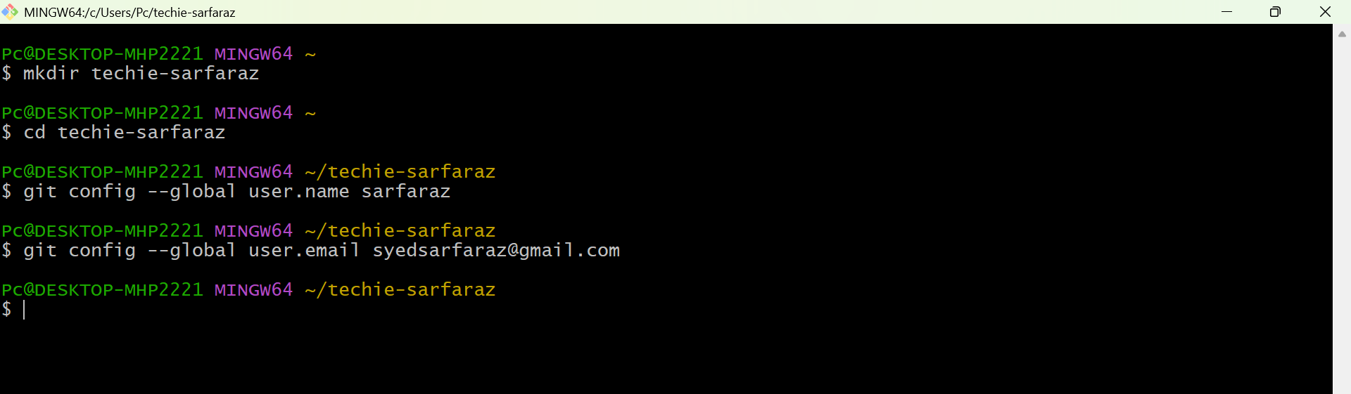

Start git
$ git init
Create files
$ touch carding.php, search.php, payment.php

Add files to staging
$ git add touch carding.php, search.php, payment.php

Check status
$ git status
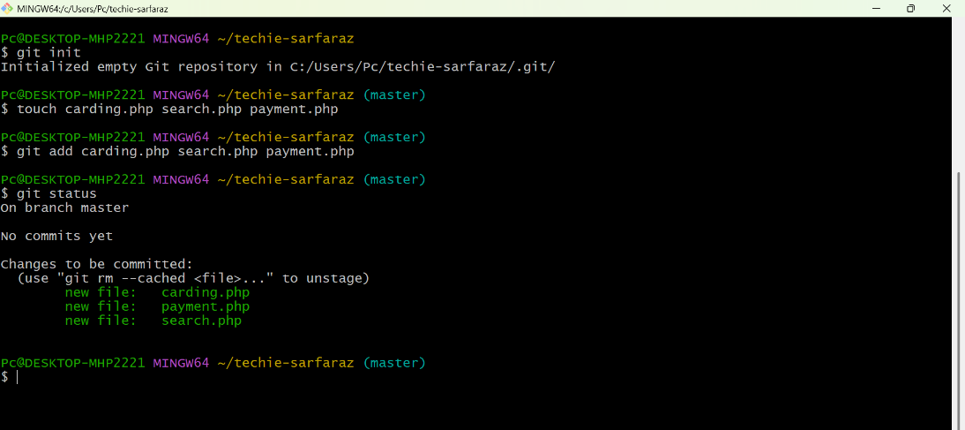

Add repository by using url of repo
$ git remote add origin https://github.com/syedsarfaraz179/docker.git

Confirm the repository connection
$ git remote -v

Commit the file
$ git commit -m “1st commit”

Check commit logs
$ git logs --online
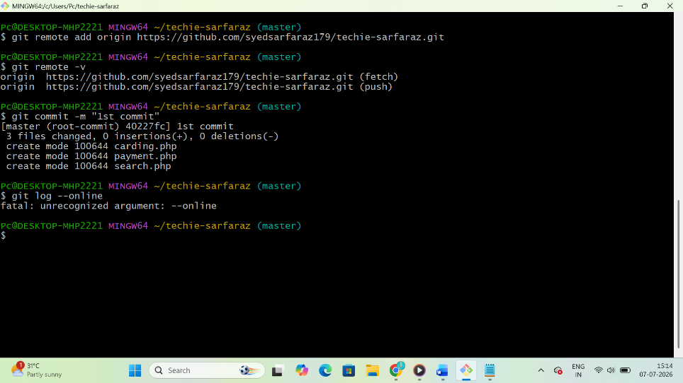

Push your files to Github Repostitory
$ git push -u origin main
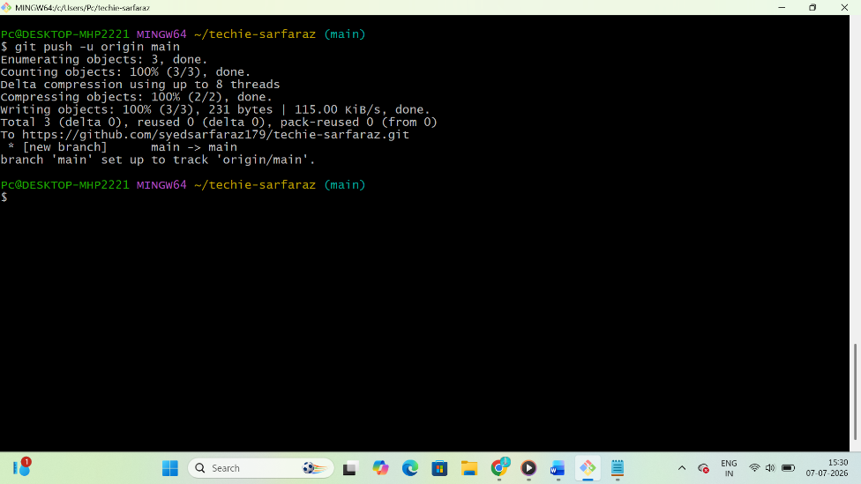

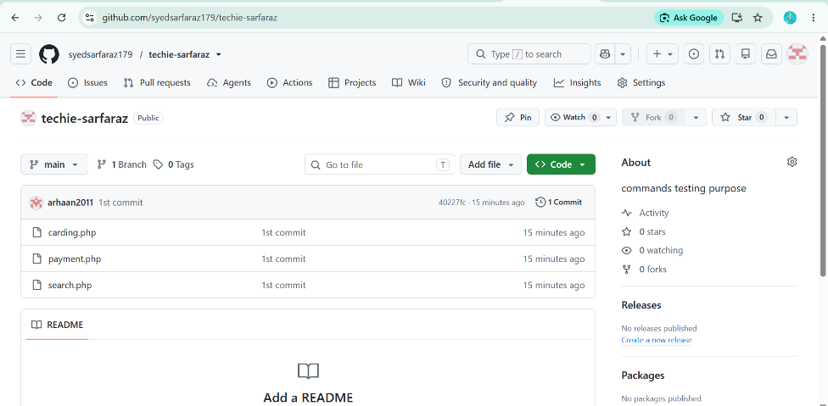

Git Branching Steps
Create new branch
$ git branch feature

Change the branch
$ git checkout feature

Delete branch
$ git branch -d master

Check list of branches
$ git branch
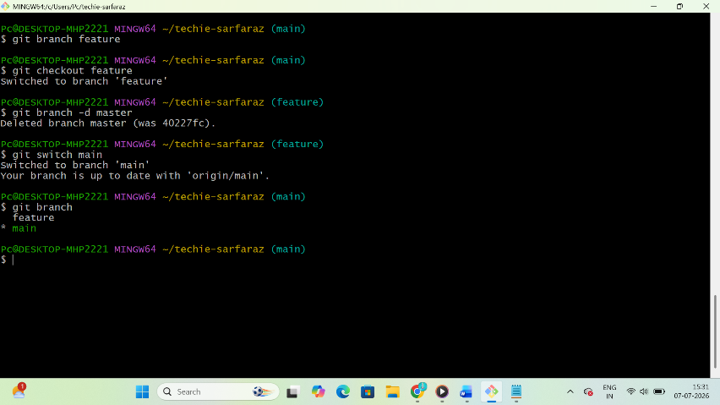

Pulling from Github
$ git pull
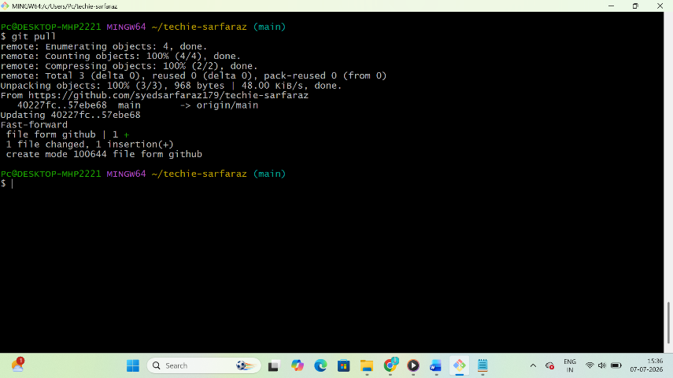

To get clone copy
$ git clone git@github.com:syedsarfaraz179/techie-sarfaraz.git
